



Data Structures & Algorithm
LAB MANUAL

Disclaimer: The content is curated from online/offline resources and used for educational purpose only
Implement Stack using Linked List

Objective:
To implement stack operations using linked list (LIFO behavior).
Equipment Required:
- Computer with Python installed, text editor/IDE.

Prerequisites:
Basic knowledge of Stack operations, linked list basics.

Problem Statement:
Write a program to Use a singly linked list to implement push and pop operations.

Procedure:
- Use head as top of the stack.
- Push → insert at head.
- Pop → remove from head.

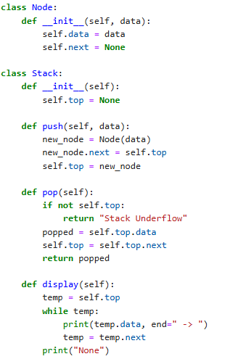
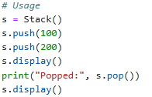

Output:
